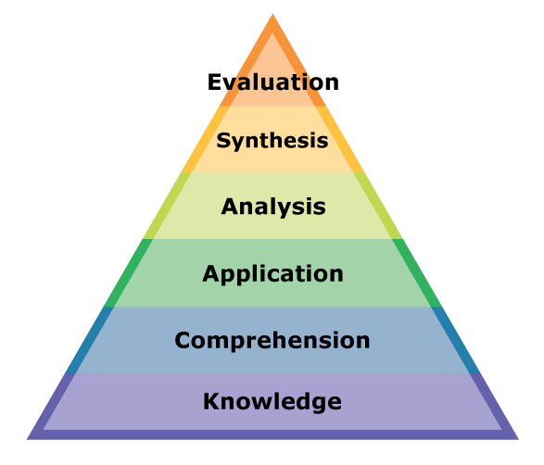

Know, define, identify,

list, locate, recall,

restate, identify

Explain, translate, describe,

express, find

Apply, use, operate, present,

demonstrate, practice

Analyze, compare, classify, organize, examine, inquire, investigate

Create, hypothesize, predict, speculate, generalize, develop, invent

Judge, recommend, conclude, evaluate, infer, consider, determine, advise